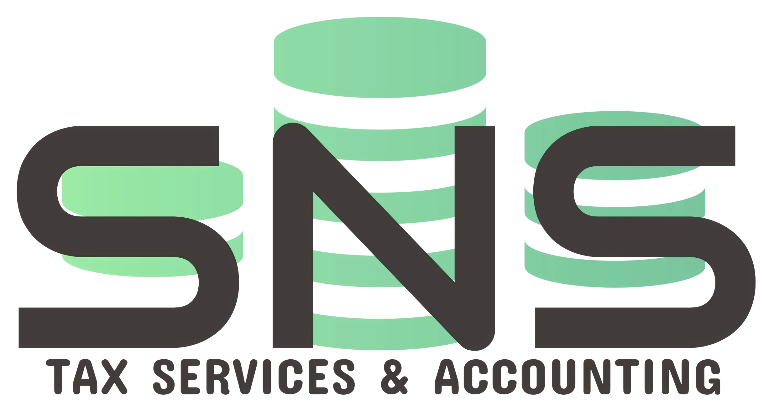
✅ Tax Return Prep Checklist
(GATHER THESE BEFORE YOU FILE)

INCOME
☐ W-2s from every employer (due to you by Feb 2)
☐ 1099-NEC for freelance or contract income
☐ 1099-INT / 1099-DIV for bank interest and dividends
☐ 1099-B for investment sale proceeds
☐ 1099-R for retirement distributions
☐ 1099-SSA for Social Security benefits
☐ 1099-DA for crypto or digital asset sales (NEW)

DEDUCTIONS
☐ 1098 for mortgage interest paid
☐ Property tax bills or receipts
☐ Charitable donation receipts and Form 8283
☐ 1098-E for student loan interest
☐ Medical expense receipts (if itemizing)

HEALTH & RETIREMENT
☐ 5498-SA for HSA contributions
☐ 5498 for IRA contributions
☐ 1095-A / B / C for health insurance coverage

NEW FOR 2025 (SCHEDULE 1-A)
☐ Tip records if deducting qualifying tips (up to $25K)
☐ Overtime records if deducting overtime pay (up to $12.5K)
☐ Auto loan statements for car loan interest (up to $10K)
☐ Income verification for phaseout thresholds (all four have limits)
BEFORE YOU FILE
☐ Portal logins verified for all financial accounts
☐ Last years return reviewed for missing forms
☐ Direct deposit information ready (IRS phasing out paper checks)

